Appendix 2
Queue length surveys

The plan below shows junctions on the main road network near the low traffic neighbourhoods that are being monitored to assess any potential impact. Queue length surveys have been undertaken in order to assess any changes in congestion and delay.

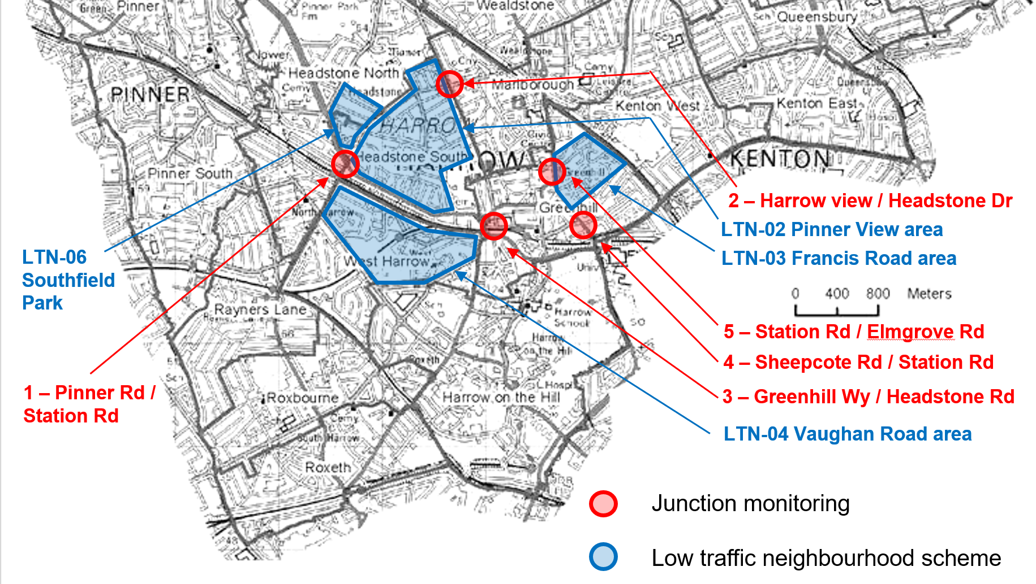

The dates for data collection are as follows:

Survey dates:  - July 23rd and 25th and August 13th and 15th  - October 15th and 17th  - November 12th and 14th  - December 10th & 12th  - January 16th & 21st  - February 13th & 18th | Survey locations:  - A404 Pinner Road / Station Road  - Headstone Drive / Harrow View / Headstone Gardens  - Greenhill Way / Headstone Road  - A409 Sheepcote Road / Station Road  - A409 Station Road / Elmgrove Road / Hindes Road

The table below gives details of the surveys. The figures show maximum queue lengths for all vehicles at all arms of the junction.

AM (7am – 9am)  Inter-peak (12 noon – 2pm)  PM (3pm – 7pm) |  | Weekday |  |  | Weekend
Junction | Month | AM | Inter peak | PM | AM | Inter peak | PM
1 - A404 Pinner Road / Station Road | July | 84 | 120 | 45 | 66 | 148 | 116
 | October | 178 | 163 | 198 | 84 | 198 | 181
 | November | 195 | 163 | 145 | 58 | 158 | 150
 | December | 219 | 179 | 211 | 88 | 182 | 166
 | January | 80 | 75 | 93 | 47 | 70 | 96
 | February | 73 | 107 | 132 | 50 | 97 | 97
2 - Headstone Drive / Harrow View / Headstone Gardens | July | 97 | 132 | 175 | 99 | 129 | 152
 | October | 202 | 162 | 200 | 127 | 172 | 165
 | November | 174 | 114 | 186 | 59 | 123 | 133
 | December | 208 | 154 | 160 | 88 | 167 | 160
 | January | 89 | 96 | 129 | 52 | 88 | 90
 | February | 102 | 115 | 177 | 51 | 104 | 117
3 - Greenhill Way / Headstone Road | August | 87 | 100 | 139 | 60 | 120 | 113
 | October | 99 | 108 | 126 | 85 | 107 | 129
 | November | 125 | 105 | 140 | 87 | 160 | 160
 | December | 115 | 112 | 128 | 89 | 129 | 132
 | January | 81 | 79 | 108 | 50 | 84 | 91
 | February | 84 | 89 | 123 | 56 | 115 | 108
4 - A409 Sheepcote Road / Station Road | July | 43 | 56 | 69 | 29 | 57 | 53
 | October | 69 | 57 | 68 | 42 | 70 | 71
 | November | 61 | 54 | 63 | 25 | 56 | 56
 | December | 64 | 68 | 75 | 43 | 61 | 67
 | January | 42 | 55 | 55 | 22 | 42 | 50
 | February | 35 | 53 | 64 | 26 | 51 | 55
5 - A409 Station Road / Elmgrove Road / Hindes Road | July | 96 | 93 | 126 | 63 | 98 | 111
 | October | 105 | 76 | 120 | 73 | 95 | 95
 | November | 141 | 105 | 129 | 58 | 113 | 105
 | December | 157 | 115 | 153 | 72 | 112 | 110
 | January | 79 | 92 | 103 | 45 | 83 | 85
 | February | 78 | 92 | 107 | 44 | 103 | 95

